T2 Fit Plug-in
Antoine Rosset, 2004

Compute T2 time map from a series of TE

- Open your series with multiple TE and select the T2 Fit plug-in from the plugins menu – image filter submenu. If you are using DICOM files, the TE values are automatically available.

- Create a ROI on the series, move it to see the T2 curve.
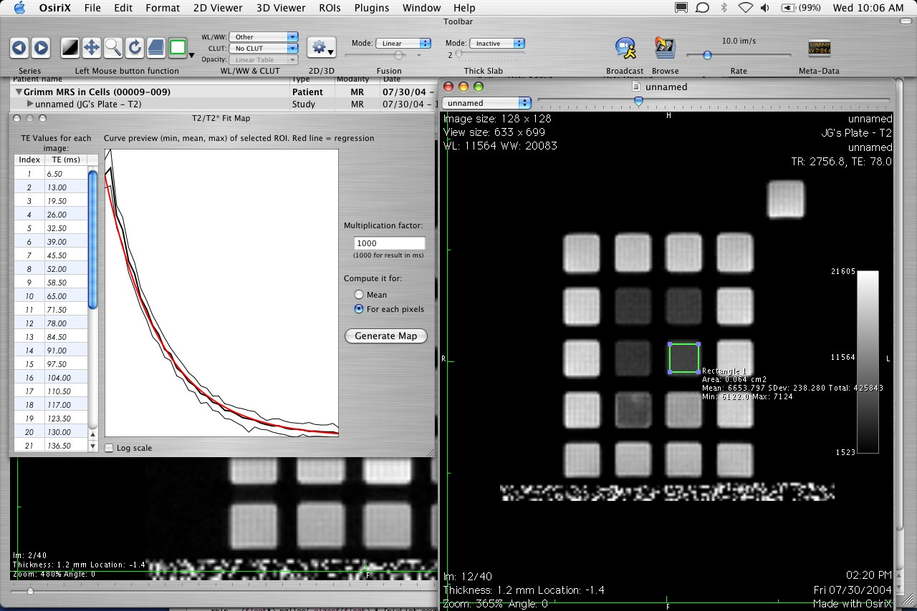

- Click on Generate Map to produce an image with the T2 values of selected ROI. Select a CLUT for the new image.
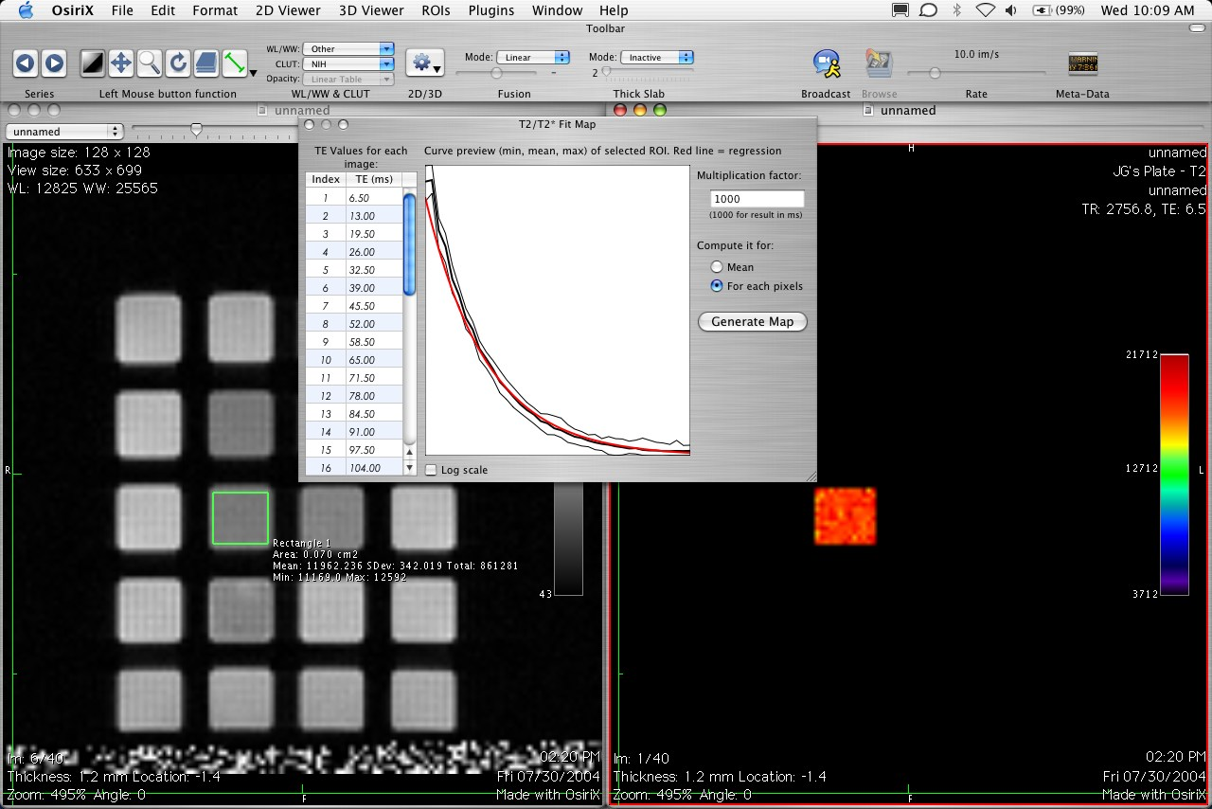

- Drag & Drop this new image on your series of TE images.
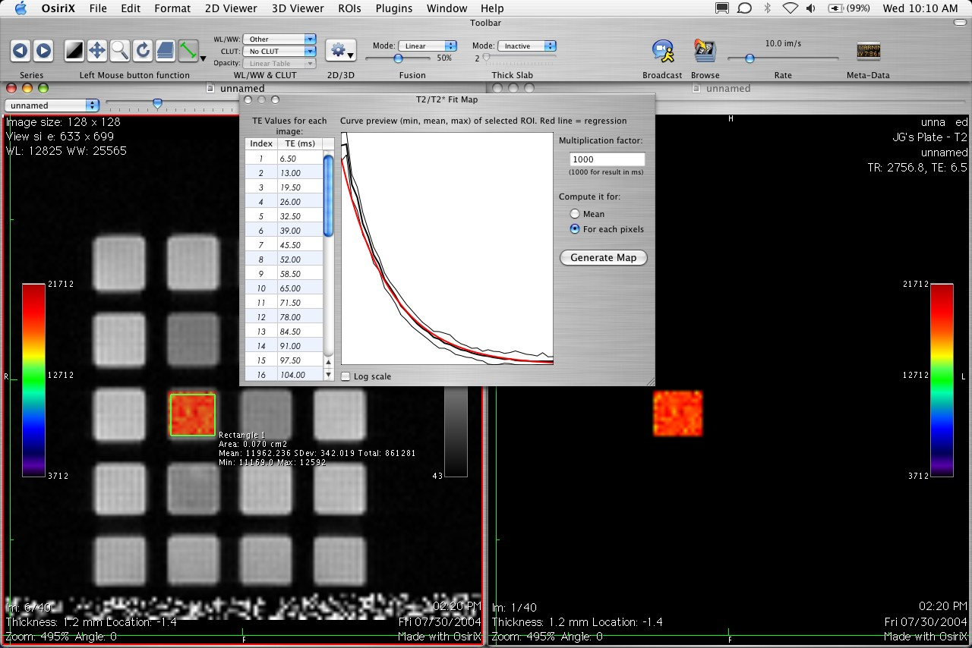

- If you want to produce another T2 are on the same series: simply move the ROI and click “Generate Map” button again.
